TITLE OF THE PROJECT

**Hotel Room Booking Application**

**REPORT**

HARMAN C++ Batch 5

TEAM MEMBERS

* + - * + Bhagya Shri T
        + Prakruthi C Gowda
        + Soumya Basapur
        + Vinay Kasimahanthi

**Business Requirements Specification (BRS)**

1. **Background of the project**

The hotel industry is a business venture for the owner and a solace for the traveler and/or tourist. A customer can get stranded in the quest to secure a hotel room to pass the night if he/she has not made adequate plans. So, what happens if you move around sometimes very late in the night in search of a room and all close by hotels are fully booked? Other times you may be lucky to have the contact number of the hotel to reach them to book for a room. But do the hotel attendants really ensure to keep a room for you? You would be lucky to go and get a room booked for you. They are quick to serve those who walk in rather than those who may get access to them on phone to book a room. On other times too, if you have friends or family members in the area you want a room booked, they have to go and do the checking for you. Such things used to happen many times in the past. Back then, there was no system in place that bonded the hotel and the customer that the customer actually booked a room. In order to resolve such issues, online hotel room booking systems came into the picture.

1. **Goals of project**

The goal is to develop a desktop-based application that allows customers to make enquiries online and book for services providing the required details. A few new features of the project have been mentioned below.

* Well laid out information about the hotels available for the users to book.
* Replacement of the manual hotel room booking system with online reservation system, which is very beneficial to the users.
* Management can pull reports anytime, in order to put the necessary measures in place.
* The customer information is effectively secured in this system.

1. **Problem Statement**

Develop an application to facilitate the users to book hotel rooms based on their preferences.

1. **Solution / Proposed System**

Proposed system will be a database-driven hotel room booking application. The user can login by entering valid details, check the availability of rooms in a particular hotel, filter rooms based on their preferences and make bookings. Many hotels currently use a manual booking system and that requires customers to be physically present in hotels to book rooms or avail some service by walking to the receptionist, calling them on phone or using a third-party option. Any enquiry to be made demanding feedback must usually be forwarded to the hotel in person. Sometimes management is given false reports concerning the work flow of the hotel and employees also give falsified pricing information to customers from time to time. In order to avoid these issues and enable a hassle-free experience, we designed this project.

1. **Users of project**

**Customer -** the person who is in need of a room in a hotel.

It is a client-side application.

**f) Requirements**

**Functional Requirements**

1. Entry of the details.
2. Filtering the rooms based on preferences.
3. Displaying the information and asking for confirmation.
4. Asking the guest/customer whether to continue or cancel.

**Non-Functional Requirements**

1. Asking the guest/customer to make the payment in one instalment or go with the *Staggered Payment* option.
2. Asking the guest/customer for an additional bed or
3. Offering discount to the customer/guest, in case they make the payment 3 days prior to checking in.

**DATABASE Design**

**City Name: Madurai**

|  |  |
| --- | --- |
| Hotel ID | Hotel Management |
| 1 | Ashoka Grand |
| 2 | Hotel Taj |
| 3 | Leela Palace |
| 4 | Lalith Mahal |

**City Name: Chennai**

|  |  |
| --- | --- |
| Hotel ID | Hotel Management |
| 1 | Ashoka Grand |
| 2 | Hotel Taj |
| 3 | Leela Palace |
| 4 | Lalith Mahal |

**City Name: Bangalore**

|  |  |
| --- | --- |
| Hotel ID | Hotel Management |
| 1 | Ashoka Grand |
| 2 | Hotel Taj |
| 3 | Leela Palace |
| 4 | Lalith Mahal |

**City Name: Kochi**

|  |  |
| --- | --- |
| Hotel ID | Hotel Management |
| 1 | Ashoka Grand |
| 2 | Hotel Taj |
| 3 | Leela Palace |
| 4 | Lalith Mahal |

**Architecture diagram**

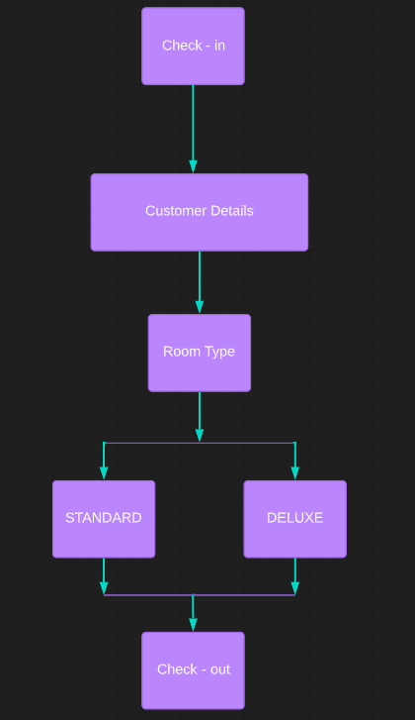

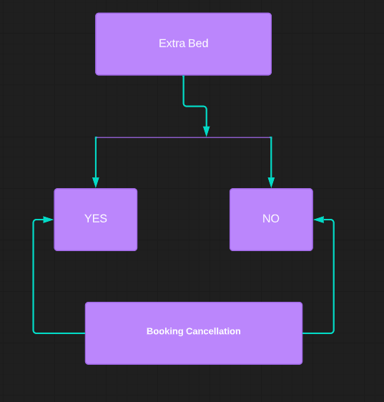

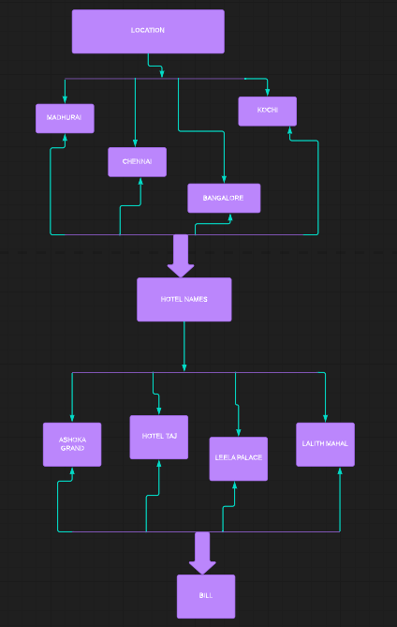

**UML Diagram**

1. **Class Diagram**

Check-in

User Details

Check user level and permission

Check permi-ssion

Check permi-ssion

Check permi-ssion

Check permi-ssion

Check permi-ssion

Check permi-ssion

Manage Hotel

Manage payment

Manage Room

Manage service

Manage food

Manage cancellation policy

1. **Use-case Diagram**

**customer**

Release Notes

**Hotel Room Booking System**

Release Notes

Introduction

The hotel industry is a business venture for the owner and a solace for the traveler and/or tourist. A customer can get stranded in the quest to secure a hotel room to pass the night if he has not made adequate plans. We designed a project which would help the guests / customers to book rooms from their personal devices, by taking all their preferences into consideration. The project aims at helping people to book rooms, without being physically present in hotels.

# Compatible Products

It is a desktop application and it has been designed mainly for Windows users.

# Upgrades

Many hotels currently use a manual booking system and that requires customers to be physically present in hotels to book rooms or avail some service by walking to the receptionist, calling them on phone or using a third-party option. Any enquiry to be made demanding feedback must usually be forwarded to the hotel in person. Sometimes management is given false reports concerning the work flow of the hotel and employees also give falsified pricing information to customers from time to time. In order to avoid these issues and enable a hassle-free experience, we designed this project.

The online Hotel Booking System provides various services to customers. A few of them are mentioned below.

* Choose the exact location
* Select a hotel in that location
* Filter the rooms based on preferences

# New Features

The proposed system is a desktop-based application that allows customers to make enquiries online and book for services providing the required details. A few new features of our project have been mentioned below.

* Well laid out information about the hotels available for the users to book.
* Replacement of the manual hotel room booking system with online reservation system, which is very beneficial to the users.
* Management can pull reports anytime, in order to put the necessary measures in place.
* The customer information is effectively secured in this system.